Yes You Can!
Relationship Enhancement Family of Family Therapies and Enrichment
The Pioneering Work of Drs. Bernard and Louise Guerney

A newly released documentary!
This is a tribute to the groundbreaking work of Drs. Bernard and Louise Guerney. It includes interviews with the Guerneys and those who have followed in their footsteps, video clips demonstrating each of them working with clients, research and publications, and descriptions of local and worldwide outreach by others. Implications for the enormous possibilities
for the future by means of prevention and positive change are envisioned.

“…What the Guerneys did that was so special was to show that, with the right training and the right follow-through and support, families are capable of great things.”
Risë VanFleet, Ph.D.,
Family Enhancement and Play Therapy Center, Inc.

“…the Guerneys had a real belief that the clients had the ability to learn, to make lasting changes and to acquire the skills that traditionally, the therapists had for themselves.”
William Nordling, Ph.D.,
Founding Faculty Member of the Institute for the Psychological Sciences

“…an excellent tribute to the Guerneys and quite a strong representation of the
power of their methods.”
Steven L. Herb, Ph. D., Head of Education and Behavioral Sciences Library in the University Libraries
Affiliate Professor of Education, Pennsylvania State University

“…Yes You Can… recounts the remarkable contributions of Drs. Bernard and Louise Guerney. Their emphasis on skill-training has transformed the fields of
mental health and child, couple and family therapies. This DVD includes
excerpts of their work and historical recounting by their colleagues.
A fascinating listening experience.”
Barry G. Ginsberg, Ph.D.,
The Center of Relationship Enhancement (CORE)

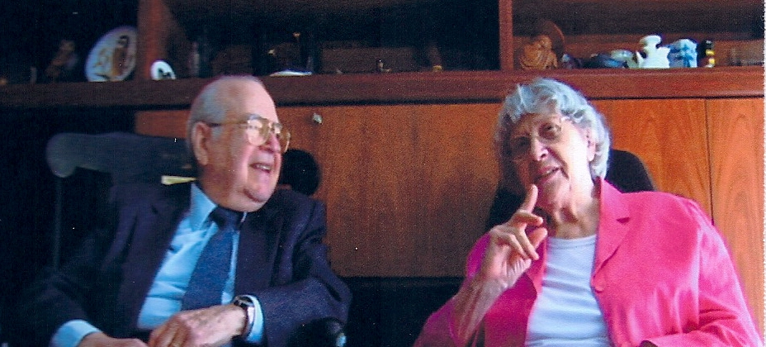

~ Bernard & Louise Guerney 2008 ~

To order this DVD for $15 (plus S/H), contact Wrenwood Studios at 814.669.4443 or email www.gallaanddan.com.

